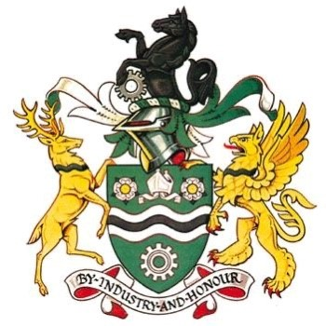

Rotherham Schools Select Parent, Spectators & anyone linked to a Player Code of Conduct

- Remember that children play for the association, not for their parents. Please leave coaching to the coaches.
- Applaud effort and good play as well as success, for both teams.
- Always respect the match officials’ decisions.
- All spectators to set a good example for young players.
- Remain outside the field of play and within the Designated Spectators’ Area (where provided).
- Let the coach do their job and not confuse the players by telling them what to do. Your child will be expected to play how the coach decides, not how you decide.
- Encourage the players to respect the opposition, referee and match officials.
- Avoid criticising a player for making a mistake – mistakes are part of learning.
- Never engage in, or tolerate, offensive, insulting, or abusive language or behaviour.
- Never get involved in barracking match officials or opponents be that players, coaches or spectators.
- All parents must communicate with Football Association staff, keeping them informed about matters affecting the young player.
- Adhere to association Polices & Procedures at all times.

